**Project Name: Pizza Sales Analysis using MySQL**

CREATE DATABASE pizza;

USE pizza;

**TABLES:**

1. **pizza_types**

CREATE TABLE pizza_types

(

pizza_type_id VARCHAR(50) PRIMARY KEY,

name VARCHAR(100),

category VARCHAR(50),

ingredients TEXT

);

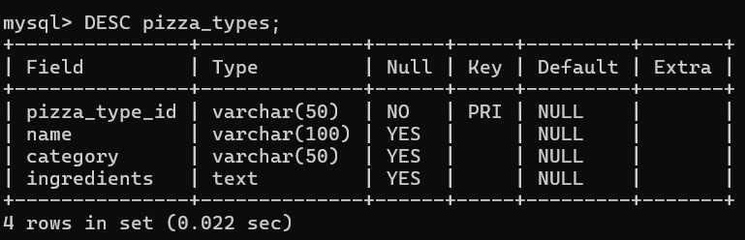

1. **pizzas**

CREATE TABLE pizzas

(

pizza_id VARCHAR(50) PRIMARY KEY,

pizza_type_id VARCHAR(50),

size VARCHAR(10),

price DECIMAL(5,2),

FOREIGN KEY (pizza_type_id) REFERENCES pizza_types(pizza_type_id)

);

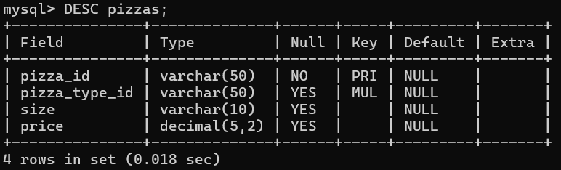

1. **orders**

CREATE TABLE orders

(

order_id INT PRIMARY KEY,

date DATE,

time TIME

);

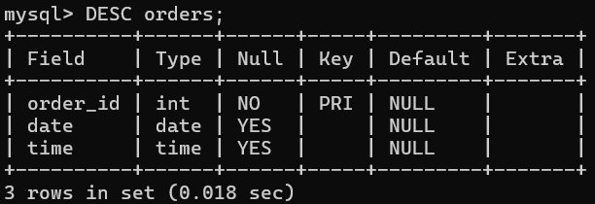

1. **order_details**

CREATE TABLE order_details

(

order_details_id INT PRIMARY KEY,

order_id INT,

pizza_id VARCHAR(50),

quantity INT,

FOREIGN KEY (order_id) REFERENCES orders(order_id),

FOREIGN KEY (pizza_id) REFERENCES pizzas(pizza_id)

);

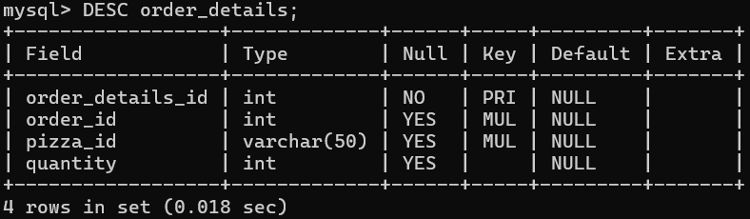

**QUESTIONS:**

**BASIC:**

1. **Retrieve the total number of orders placed.**

SELECT COUNT(order_id) as total_orders_placed

FROM orders;

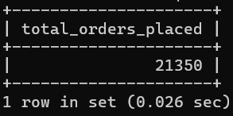

1. **Calculate the total revenue generated from pizza sales.**

SELECT sum(od.quantity * p.price) from order_details od

INNER JOIN pizzas p

ON od.pizza_id=p.pizza_id;

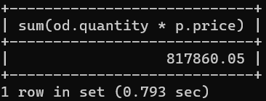

1. **Identify the highest-priced pizza.**

SELECT pt.name AS pizza_name ,

max(p.price) AS highest_price

from pizzas p

join pizza_types pt

on p.pizza_type_id = pt.pizza_type_id

group by pt.name

order by highest_price desc

LIMIT 1;

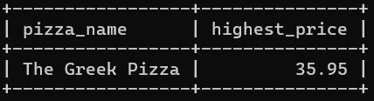

1. **Identify the most common pizza size ordered.**

SELECT p.size,

SUM(od.quantity) AS total_order

FROM order_details od

join pizzas p

ON od.pizza_id = p.pizza_id

GROUP BY p.size

ORDER BY total_order DESC

LIMIT 1;

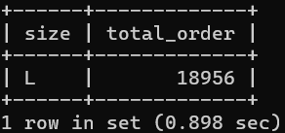

1. **List the top 5 most ordered pizza types along with their quantities.**

SELECT pt.name,

SUM(od.quantity) AS total_order

FROM order_details od

join pizzas p

ON od.pizza_id = p.pizza_id

JOIN pizza_types pt

ON p.pizza_type_id = pt.pizza_type_id

GROUP BY pt.name

ORDER BY total_order DESC

LIMIT 5;

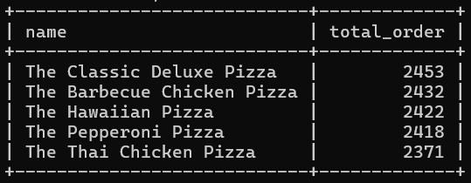

**INTERMEDIATE:**

1. **Join the necessary tables to find the total quantity of each pizza category ordered.**

SELECT

pt.category AS pizza_category,

SUM(od.quantity) AS total_quantity

FROM order_details od

JOIN pizzas p

ON od.pizza_id = p.pizza_id

JOIN pizza_types pt

ON p.pizza_type_id = pt.pizza_type_id

GROUP BY pt.category

ORDER BY total_quantity;

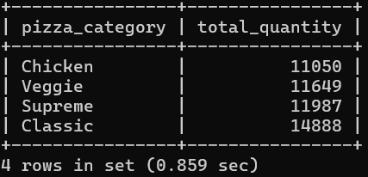

1. **Determine the distribution of orders by hour of the day.**

SELECT

HOUR(time) AS order_hour,

COUNT(*) AS total_orders

FROM

orders

GROUP BY

order_hour

ORDER BY

order_hour;

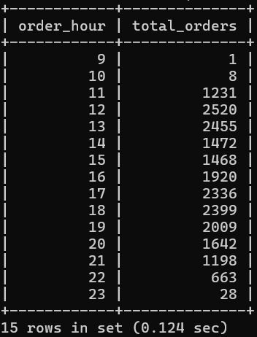

1. **Join relevant tables to find the category-wise distribution of pizzas.**

SELECT

pt.category,

COUNT(p.pizza_id) AS total_pizzas

FROM

pizzas p

JOIN

pizza_types pt ON p.pizza_type_id = pt.pizza_type_id

GROUP BY

pt.category;

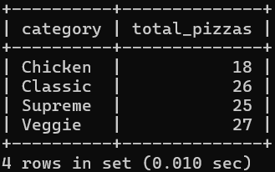

1. **Group the orders by date and calculate the average number of pizzas ordered per day**

SELECT

o.date,

SUM(od.quantity) AS total_pizzas_ordered

FROM

orders o

JOIN

order_details od ON o.order_id = od.order_id

GROUP BY

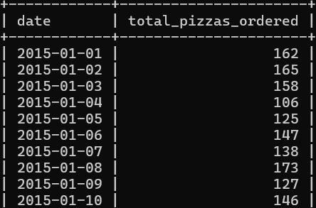 o.date

ORDER BY

o.date;

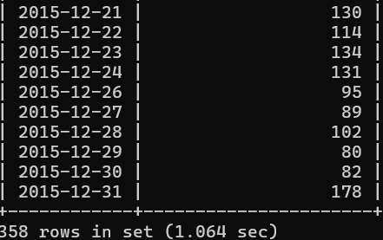

1. **Determine the top 3 most ordered pizza types based on revenue.**

SELECT

pt.name AS pizza_name,

SUM(od.quantity * p.price) AS total_revenue

FROM

order_details od

JOIN

pizzas p ON od.pizza_id = p.pizza_id

JOIN

pizza_types pt ON p.pizza_type_id = pt.pizza_type_id

GROUP BY

pt.name

ORDER BY

total_revenue DESC

LIMIT 3;

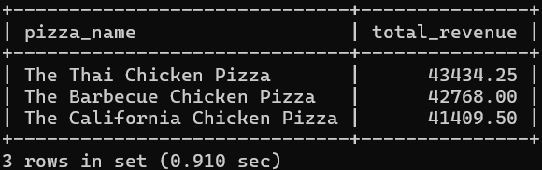

**ADVANCED:**

1. **Calculate the percentage contribution of each pizza type to total revenue.**

SELECT

pt.name AS pizza_name,

SUM(od.quantity * p.price) AS revenue,

ROUND(SUM(od.quantity * p.price) / SUM(SUM(od.quantity * p.price)) OVER () * 100, 2) AS percentage_of_total_revenue

FROM

order_details od

JOIN

pizzas p ON od.pizza_id = p.pizza_id

JOIN

pizza_types pt ON p.pizza_type_id = pt.pizza_type_id

GROUP BY

pt.name

ORDER BY

percentage_of_total_revenue DESC;

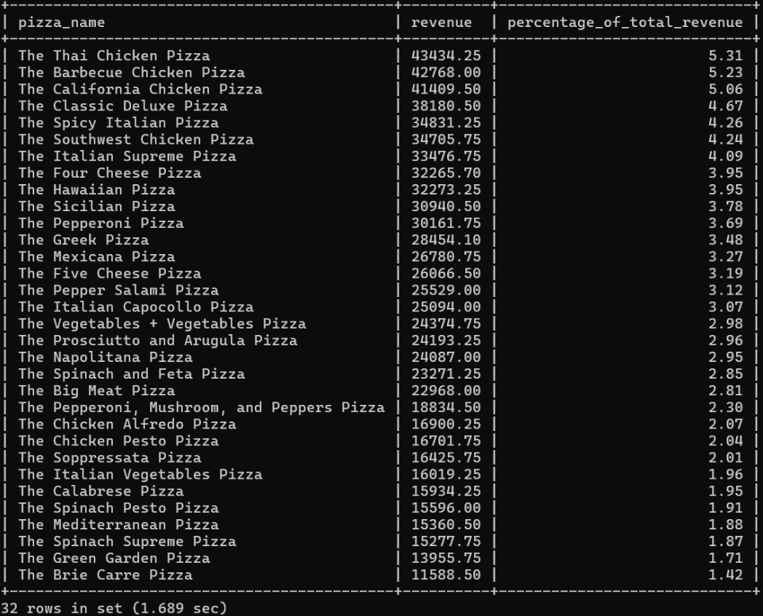

1. **Analyze the cumulative revenue generated over time.**

SELECT

o.date,

SUM(od.quantity * p.price) AS daily_revenue,

SUM(SUM(od.quantity * p.price)) OVER (ORDER BY o.date) AS cumulative_revenue

FROM

orders o

JOIN

order_details od ON o.order_id = od.order_id

JOIN

pizzas p ON od.pizza_id = p.pizza_id

GROUP BY

o.date

ORDER BY

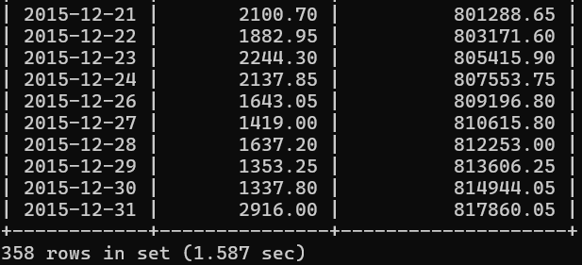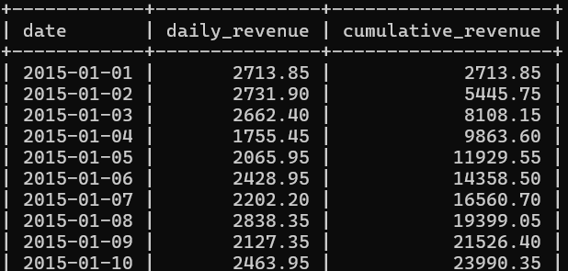 o.date;

1. **Determine the top 3 most ordered pizza types based on revenue for each pizza category.**

WITH revenue_per_pizza AS (

SELECT

pt.category,

pt.name AS pizza_name,

SUM(od.quantity * p.price) AS revenue

FROM

order_details od

JOIN pizzas p ON od.pizza_id = p.pizza_id

JOIN pizza_types pt ON p.pizza_type_id = pt.pizza_type_id

GROUP BY

pt.category, pt.name

)

SELECT

category,

pizza_name,

revenue

FROM (

SELECT

*,

ROW_NUMBER() OVER (PARTITION BY category ORDER BY revenue DESC) AS rank_in_category

FROM

revenue_per_pizza

) ranked

WHERE rank_in_category <= 3

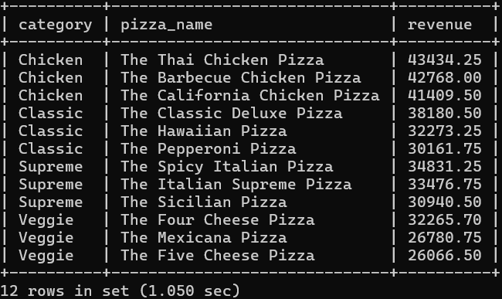ORDER BY category, revenue DESC;